**1.Executive Summary: EasyMoney Application**

The **EasyMoney** application is a revolutionary financial platform that combines the best features of Chime, TurboTax, MoneyTap, and BRAC NGO to provide users with a comprehensive suite of financial services. Designed to empower individuals and businesses alike, EasyMoney offers seamless banking, tax management, personal finance, and philanthropic support all in one user-friendly application.

**Key Features:**

1. **Banking Simplified:** EasyMoney provides Chime-like features with a user-centric approach to banking. Users can open accounts within minutes, access early paychecks, receive real-time transaction alerts, and enjoy fee-free overdraft options. The application's intuitive interface ensures effortless money management.
2. **Smart Tax Solutions:** The TurboTax-inspired tax management feature offers users a hassle-free way to file taxes. With step-by-step guidance, automatic data import, and AI-driven error checks, users can maximize their returns while ensuring compliance with tax regulations.
3. **Flexible Credit Line:** MoneyTap-like flexibility is integrated into EasyMoney, allowing users to access a flexible credit line. This feature promotes responsible borrowing, offering financial support when needed while allowing users to manage their credit health effectively.
4. **Comprehensive Financial Insights:** EasyMoney's personal finance features empower users to track their expenses, set budgets, and monitor their financial goals. The app's MoneyTap-like tools ensure that users make informed financial decisions and work towards long-term stability.
5. **Socially Responsible Giving:** Inspired by BRAC NGO's philanthropic endeavors, EasyMoney facilitates charitable contributions and community support. A percentage of certain transactions can be automatically directed towards vetted NGOs and social initiatives, fostering a sense of social responsibility among users.
6. **share**

**Market Impact:**

The EasyMoney application enters the market as an all-in-one solution, catering to individuals and businesses seeking convenience, efficiency, and financial empowerment. By integrating the strengths of Chime, TurboTax, MoneyTap, and BRAC NGO, EasyMoney is positioned to disrupt the financial technology landscape, attracting users who value comprehensive services that simplify their financial lives.

**Competitive Advantage:**

EasyMoney's unique selling proposition lies in its ability to consolidate essential financial services under a single platform. By combining the strengths of established brands in banking,

tax management, personal finance, and philanthropy, the application eliminates the need for users to navigate multiple apps, saving time and streamlining their financial activities.

**Monetization:**

EasyMoney adopts a freemium model, offering a basic set of features for free while providing premium tiers with enhanced functionality at a subscription fee. Revenue is further augmented by partnering with financial institutions for seamless fund transfers, and a small percentage of transaction amounts contributes to the philanthropic arm of the application.

In conclusion, EasyMoney presents a game-changing financial application that amalgamates the best features of Chime, TurboTax, MoneyTap, and BRAC NGO. By offering comprehensive financial services in one intuitive platform, EasyMoney is poised to empower users, simplify their financial decisions, and promote social responsibility through every transaction.

**2. Problem Statement:**

In Bangladesh's financial landscape, the absence of accessible financial services for the unbanked and underbanked is a pressing issue. With traditional banking methods falling short in addressing their needs, financial exclusion and limited economic opportunities persist. The need for a **user-friendly** and **tech-savvy** alternative is evident, especially in a country with high mobile penetration but low financial inclusion rates. **Easy-Money** aims to bridge this gap, providing a digital platform that **simplifies** financial transactions and empowers millions without access to formal banking services. By revolutionizing financial transactions, **Easy-Money** has the potential to drive inclusive economic growth and empowerment, creating a more equitable financial landscape for all Bangladeshis.

**3. Market Analysis:**

As a Financial app, **Easy-Money** will Focus on improving what the existing MFS are **lacking** and adding **new** services that have **high customer needs**.

One of the new features we want to introduce is **Fintech lending**. First, we need to see the history of **microcredit organizations** in Bangladesh.

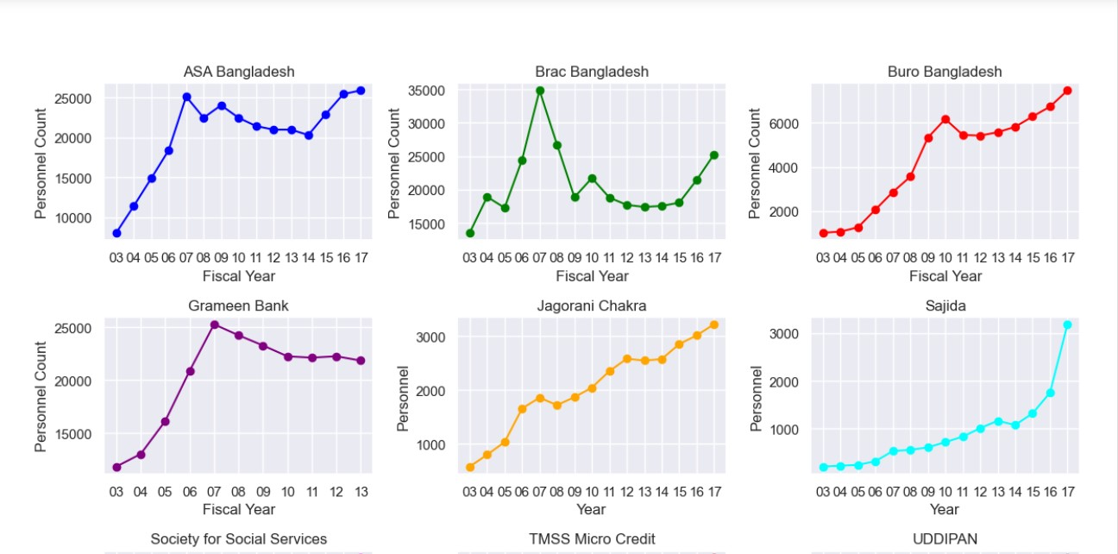

In the above visualization, we see the number of office staffs were increasing rapidly for top MFIs but during 2007 to 2010 the number has **decreased** because of widespread **delinquency**, ghost-account opened by the staffs themselves to full-fill their monthly targets and some of the owners felt the need to **digitize** their operations.

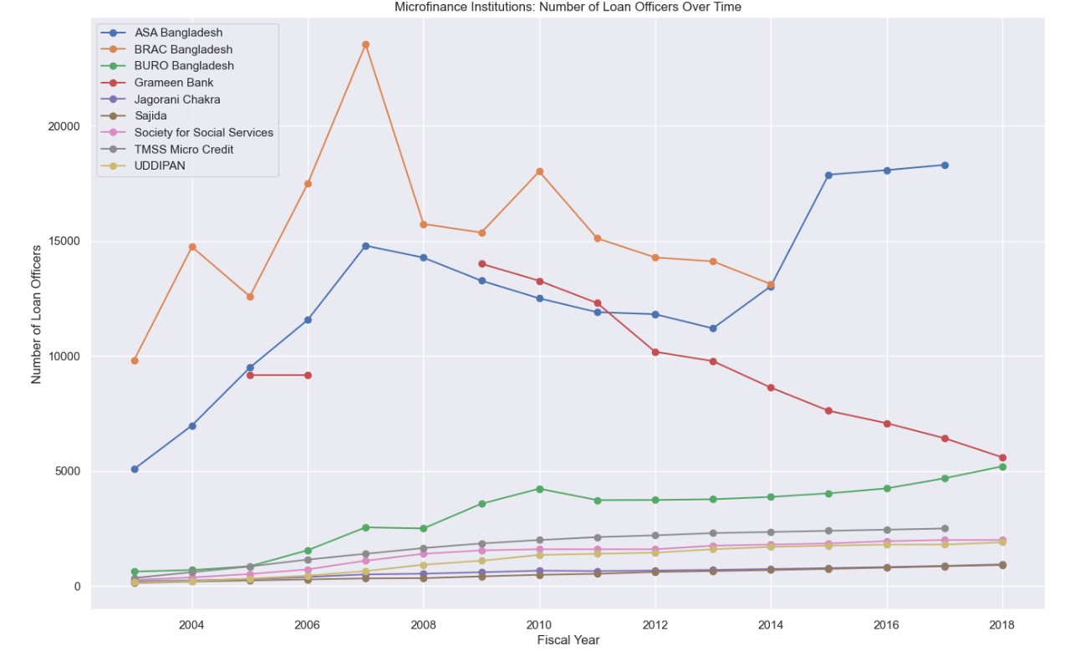

Similarly, in the figure above we can see the number of loan-officers in the top MFIs **decreased** during the 2007 to 2010 period.

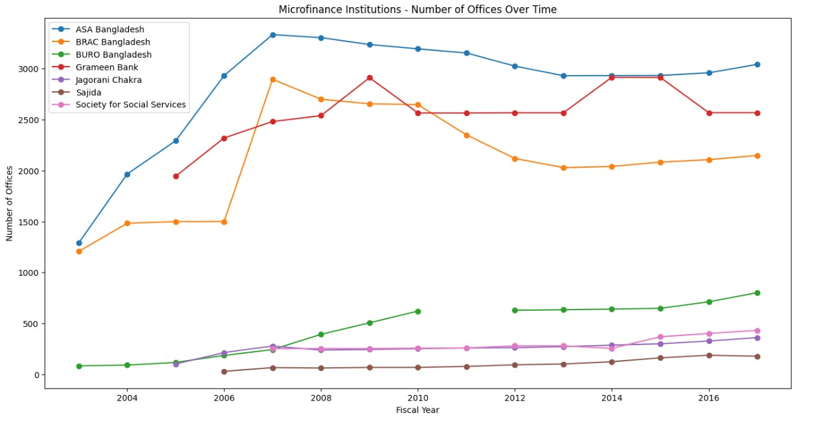

Even the branch numbers also got reduced during the same period.

But at the same time, number of active borrowers still **increased** despite all these inconveniences.

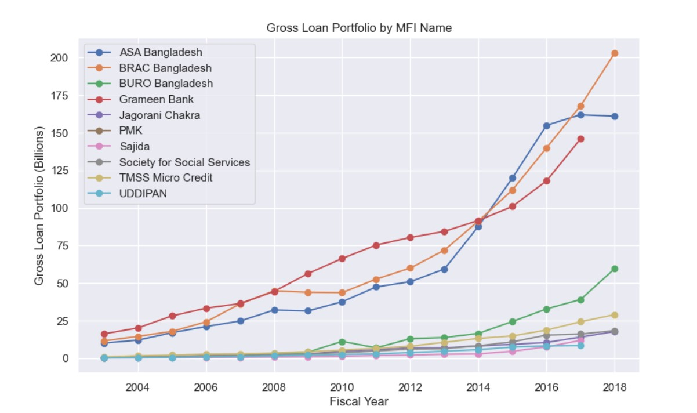

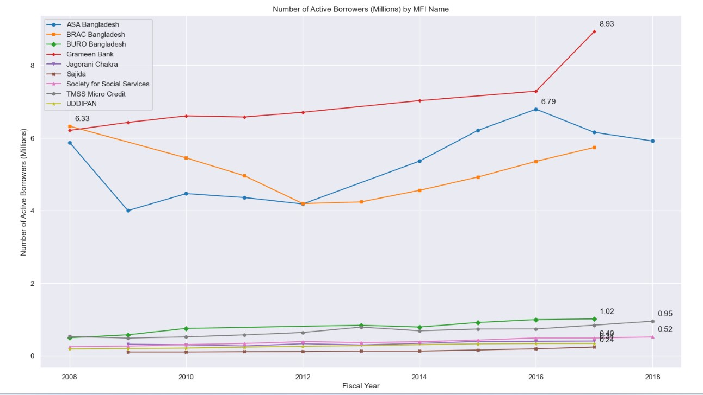

In the Mobile Financial Service sector, there are **15** organizations. **Bkash** is the market leader among the MFIs with more than **40%** share. **Nagad** is the fastest growing MFI. BKash, Nagad, Rocket and SureCash cover **95%** market share in the MFS sector.

In the graph below we can see that number of agents increasing every year to facilitate the ever-growing customer demand.

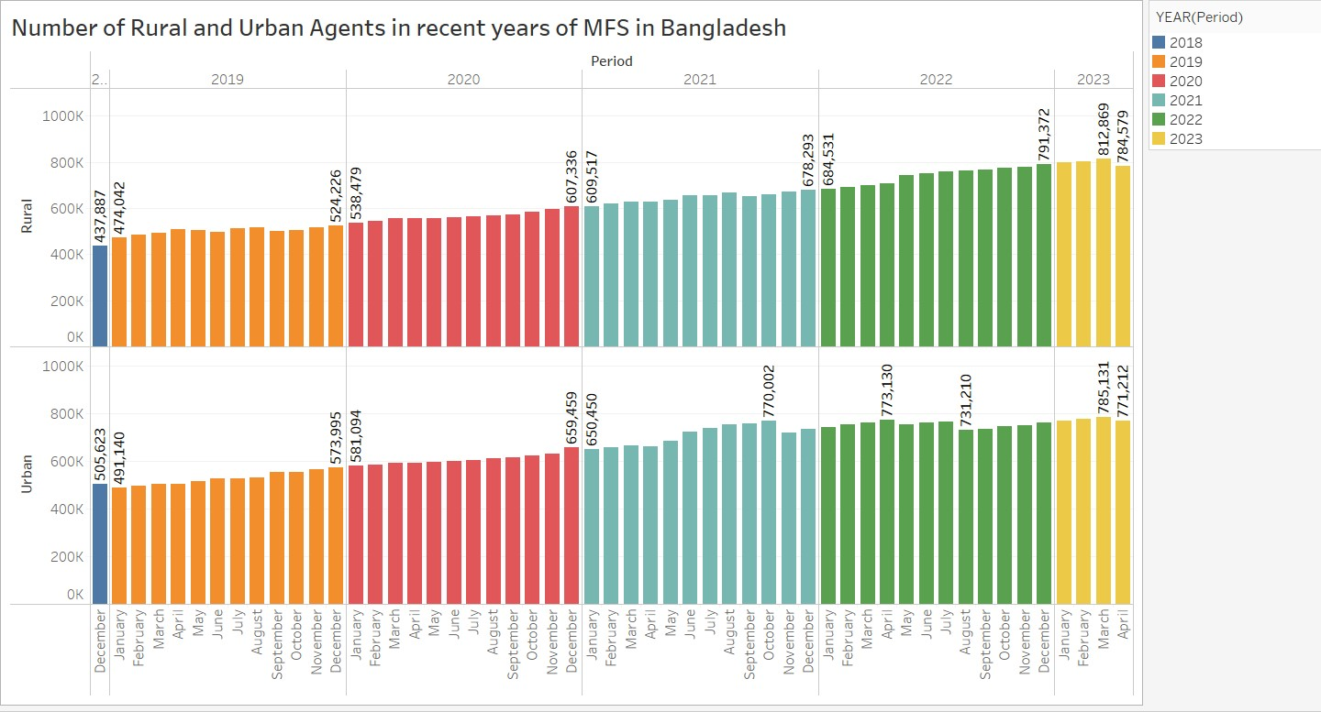

In the next visualization we can see that more MFS accounts are opened in **the rural areas** than the **urban areas** over the years. This verily justifies the purpose of the MFS as why they are created in the first place -facilitate financial services to the people who cannot afford **traditional banking**.

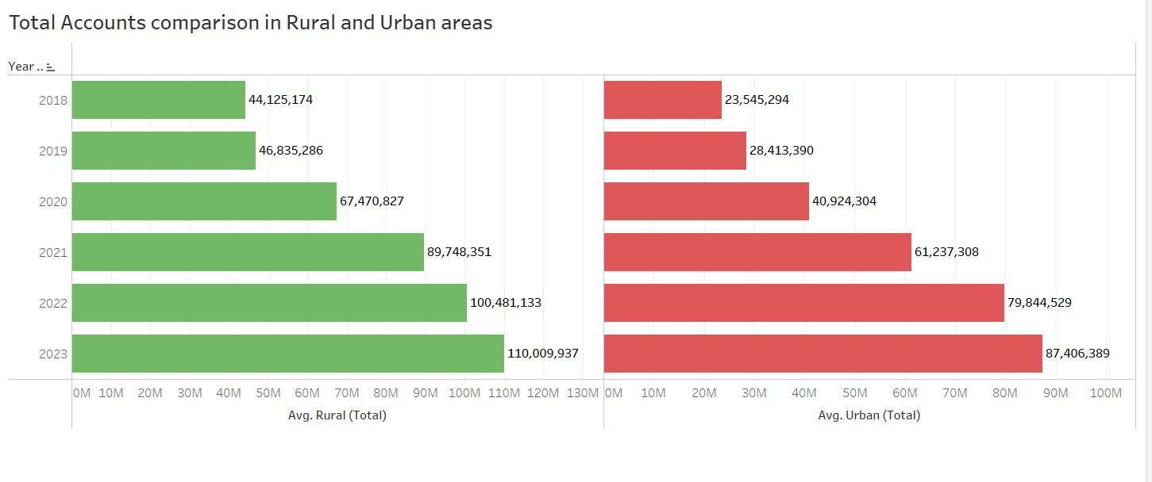

**Average daily transaction** has grown **10 billion** taka to almost **42 billion** taka in the span of just **4 years**.

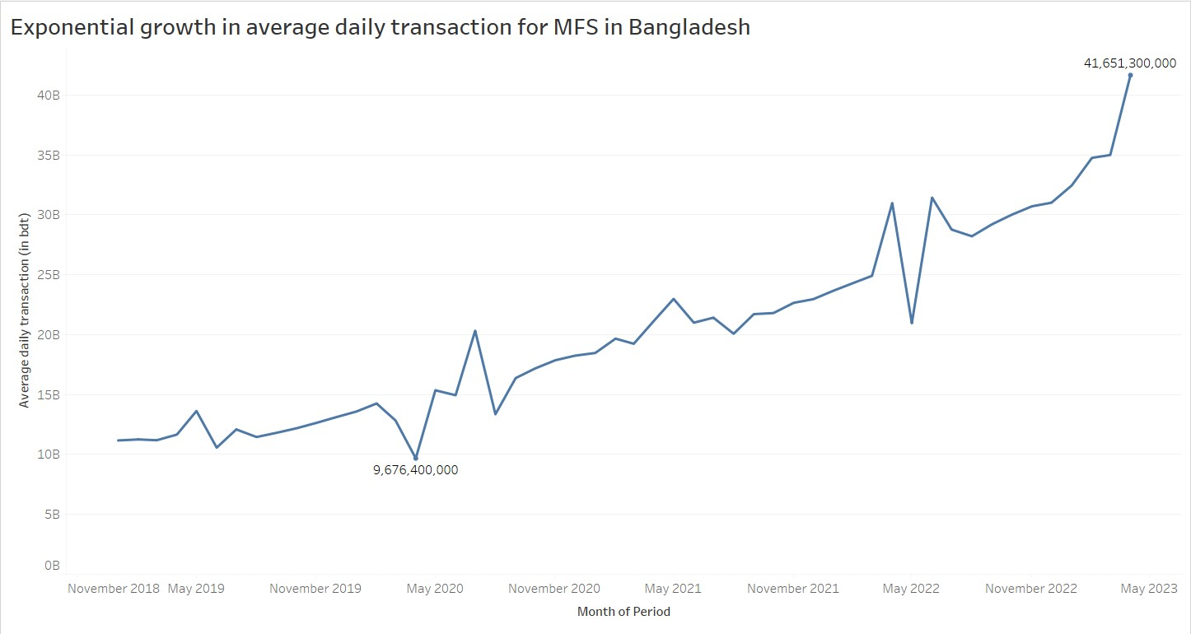

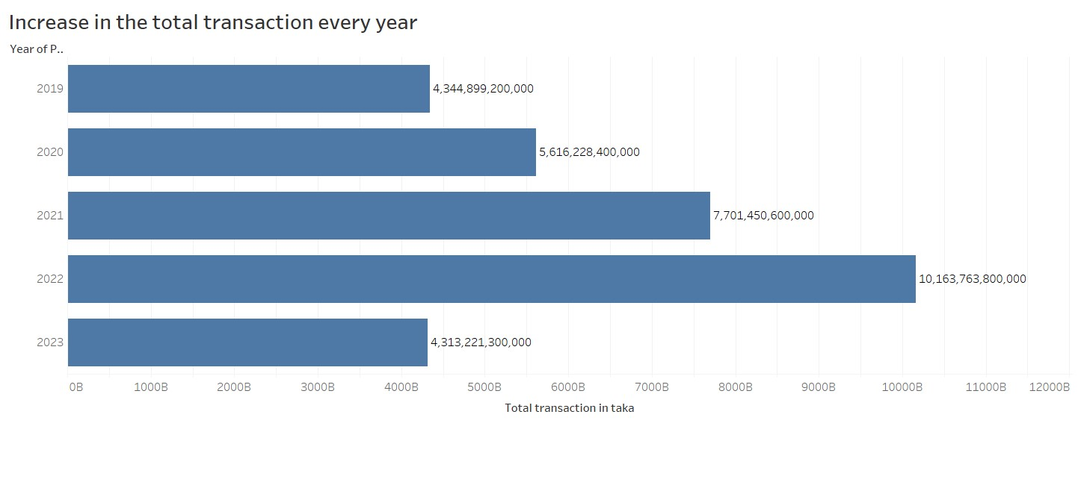

**Total transaction each year** also increased greatly as we can see in the above graph.

In the next graph we can see an interesting fact. There is a sudden growth spike in the number of registered clients during **2022**. MFIs like **Nagad** ran a plethora of campaigns to increase their customer base.

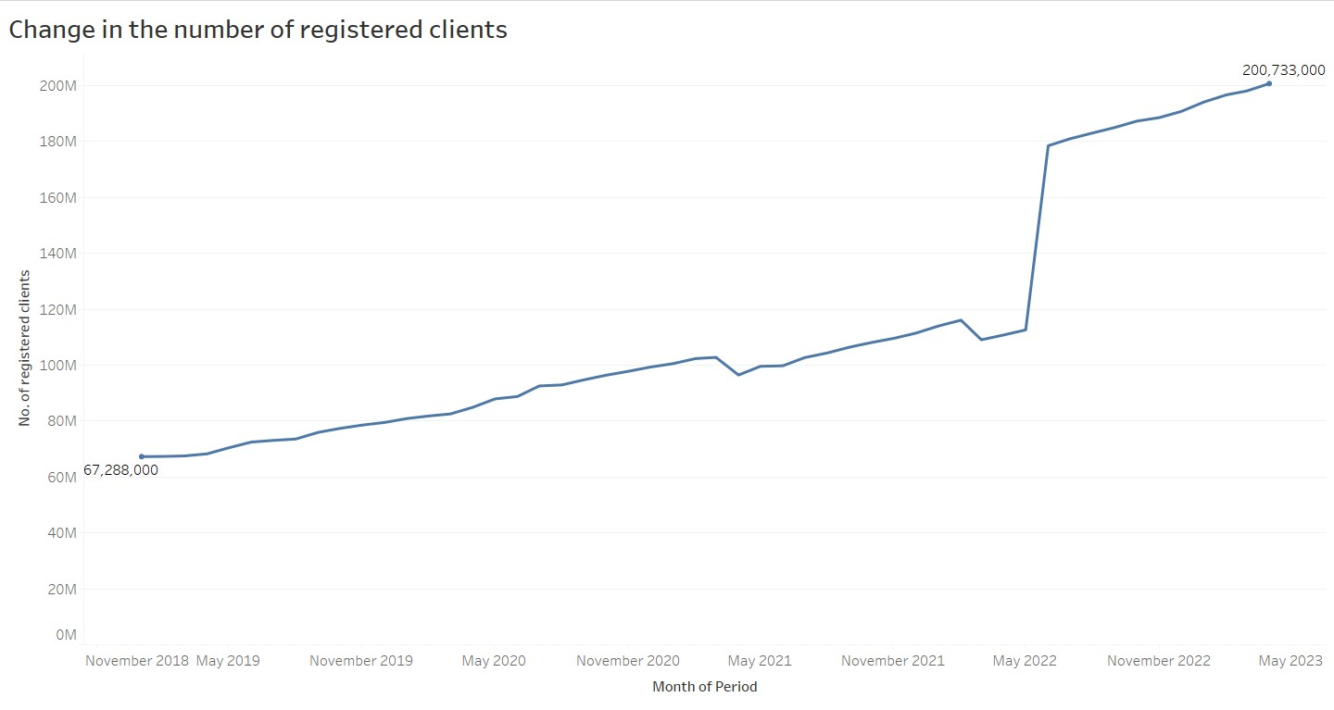

But, more interestingly, the **rate of active account conversion** decreased each year during this time. This clearly indicates that, MFIs are **somehow failing** to convert many of their new customers to regular customers of the product.

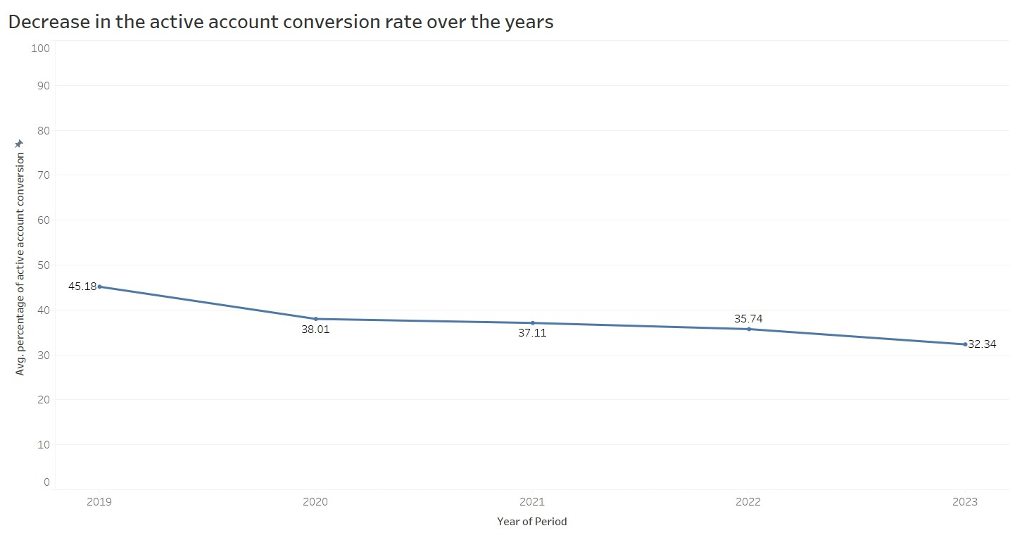

There can be a few reasons behind it –

- High transaction Fees.

-Lack of enough features that will engage the customers with the product to use it in a regular basis.

- Put maximum effort to only advertise the features that generates the highest revenues.

For example, in the below plot we can see that among all the features in MFI services only **Cash-in**, **Cash-out** and **P2P transactions** covers more than **90%** of the revenue generated each year. If we see the marketing campaign of the top MFIs, this is clearly visible that they seem to advertise heavily on these features.

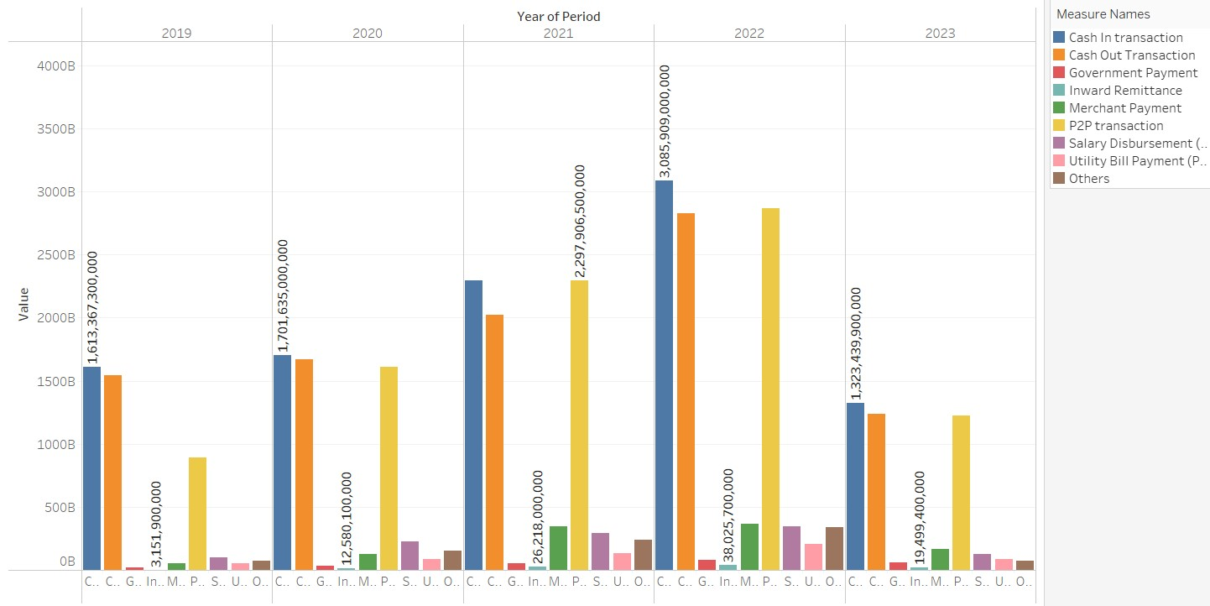

One of the new features we will integrate in our **Easy-Money** app is **online Tax-Filing**.   
Income Tax Filing is cumbersome for the eligible people because of **high-complexity**. There was no **E-Filing** app in Bangladesh for a long time. In the recent time, An E-Filing app named **BDTax** came to existence. They have reached more than **50,000** tax-payers from their platform in **2022**. It is certainly notable but the income tax market in Bangladesh is very large.

We can see in the next plot that income tax generated **34%** of total tax-revenue collected by **NBR** in **2022,** which is roughly **1029 billion taka**.

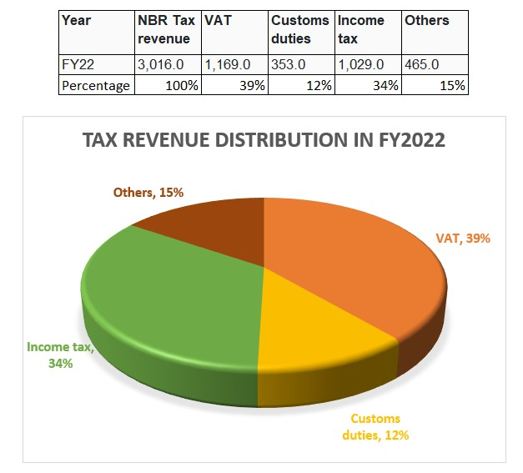

Income tax revenue has always been a steady **33-35%** of the total NBR-tax revenue.

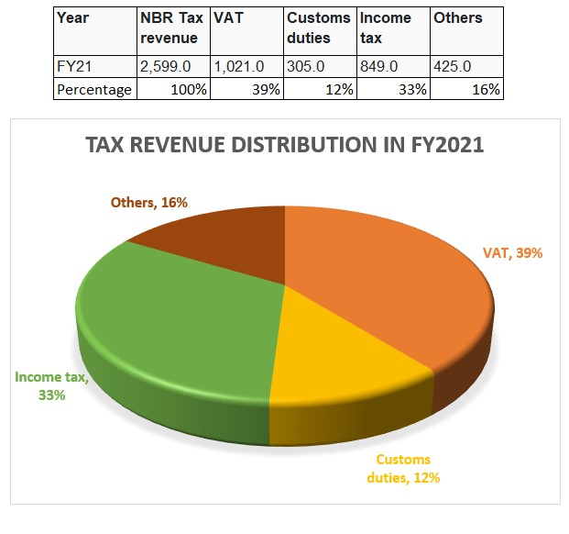

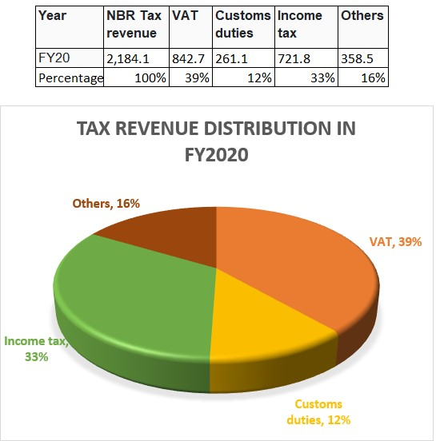

Despite the steady tax-revenue share, income tax has been **growing significantly** in the last **17** years as evident in the below plot.

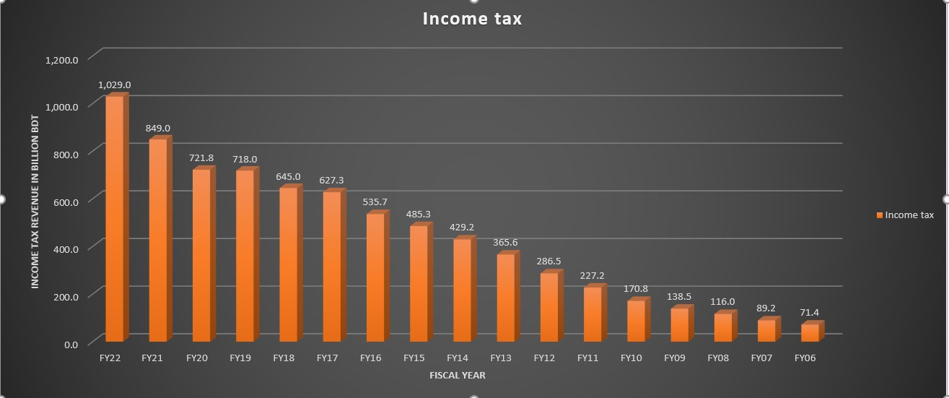

Tax Collection efficiency is still in the early **90%** , although it is growing steadily.

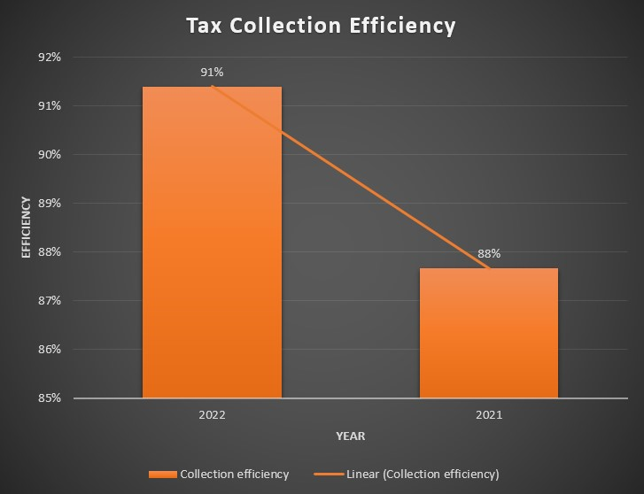

One of the main reason was the lack of easy to use **online tax filing application**.

Currently, there are approximately **87 lakh** individuals in the country who possess a **Taxpayer Identification Number (TIN)**, but only **29 lakhs ( 33%)** consistently file their tax returns each year.

**BDTax** lacks in two areas according to our findings-

1. The **full premium service** is available for only **Dhaka** and **Chittagong** Tax zones.
2. The **basic plan** which covers the lion-share of the tax-payers does not provide online tax submission feature.

Another feature of our **Easy-Money app** will be the facility to **trade on the go**. There is no **user-friendly** Trading app available in Bangladesh. In the figure below, we can see that the number of BO accounts

**Dropped significantly** in recent years. One of the main reasons is that share market in Bangladesh is still not stable. A trading app with all the modern features providing insights and portfolio of the shares is very necessary to regain the confidence of the investors and empower them to invest more actively.

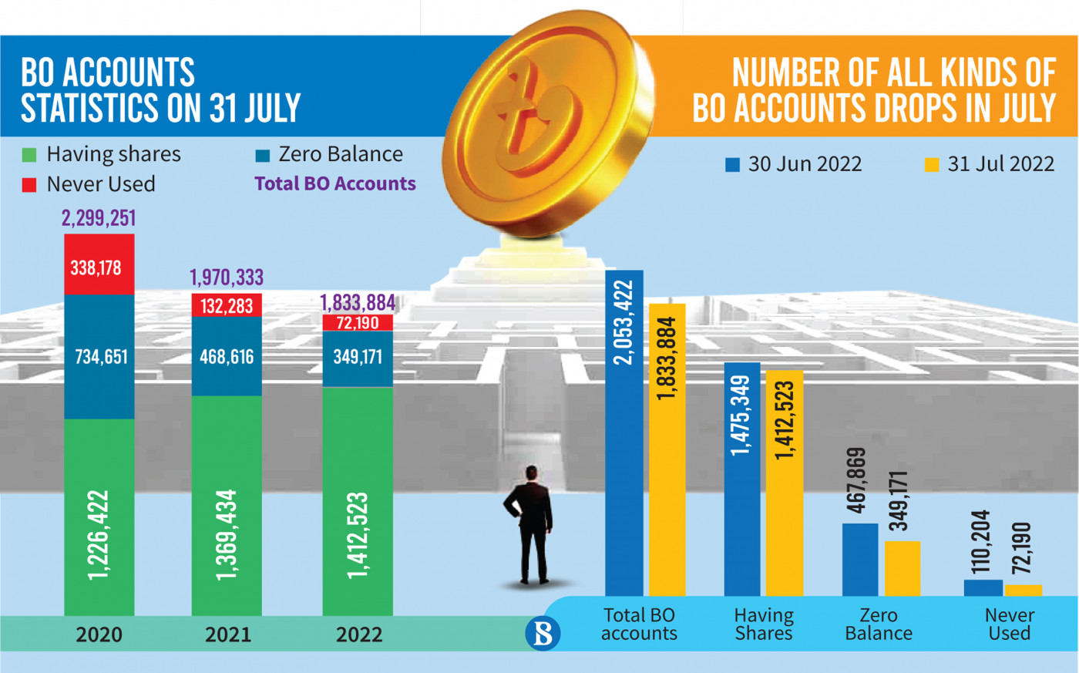

We want to introduce some unique trading features, which have gain a massive customer following in other countries of the world-

* **Social trading** : A user can instantly see which shares our **top investors** are currently investing in as well as their **overall portfolio**. Besides, they can even use the feature to automatically buy the shares which their selected top buyer is currently buying.
* **Islamic trading**: As majority of the people living in Bangladesh are muslims, we would facilitate a feature called **Islamic trading**, where the trading would be **free of any interest**.